HOMEPAGE DASHBOARD
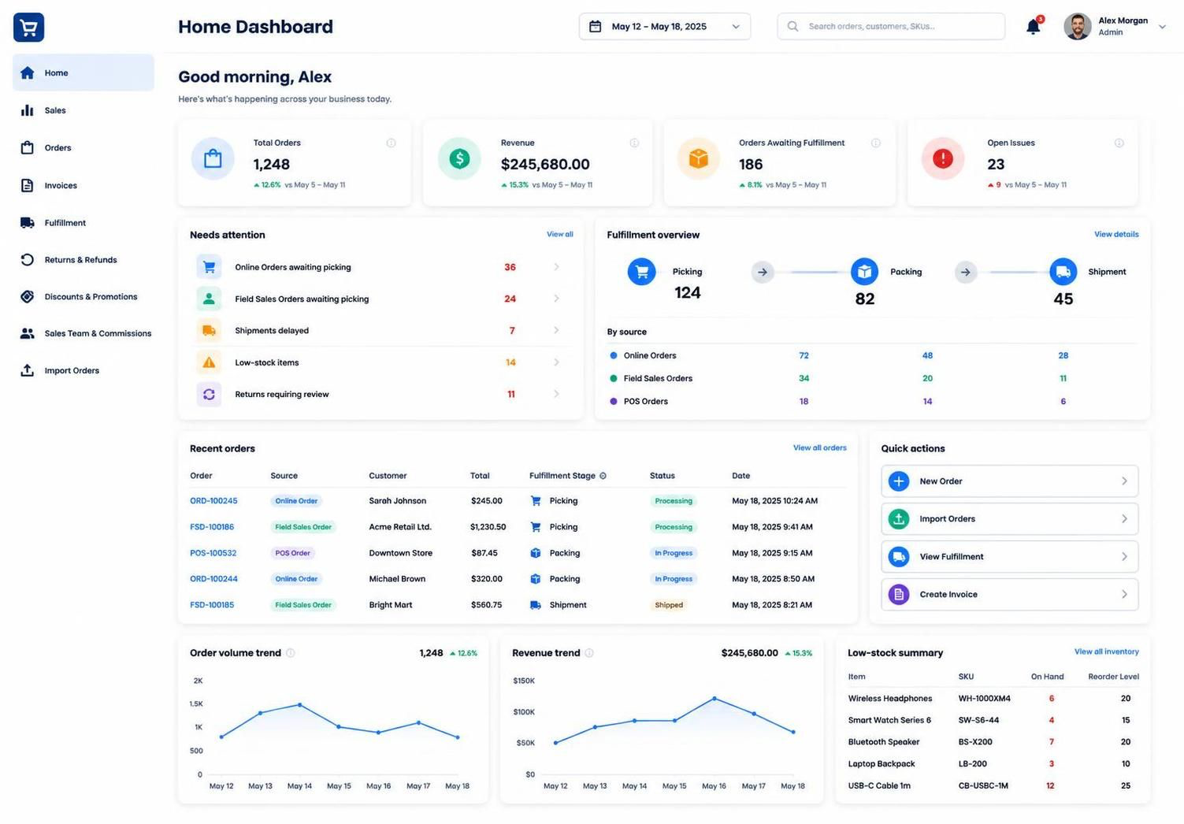
Currently Sales Dashboard and Homepage dashboards are the same. We need the homepage dashboard to be different. Follow this:

INVENTORY

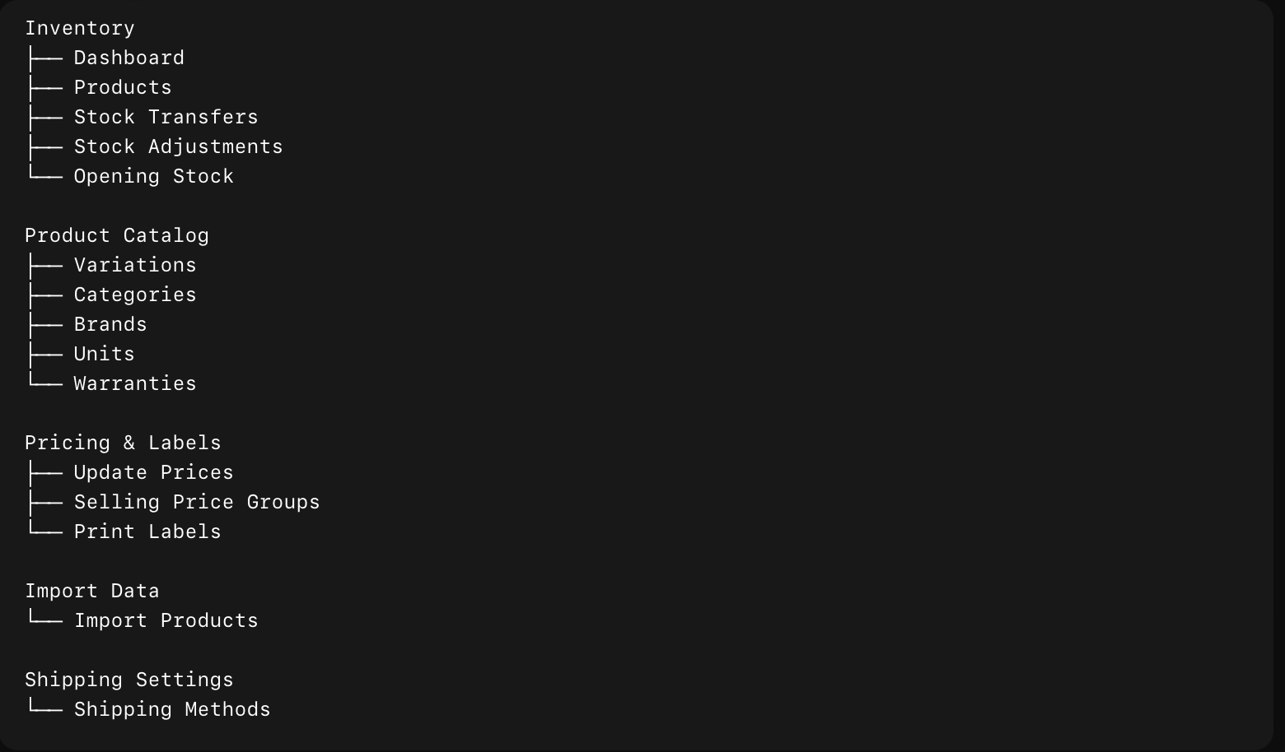

SALES

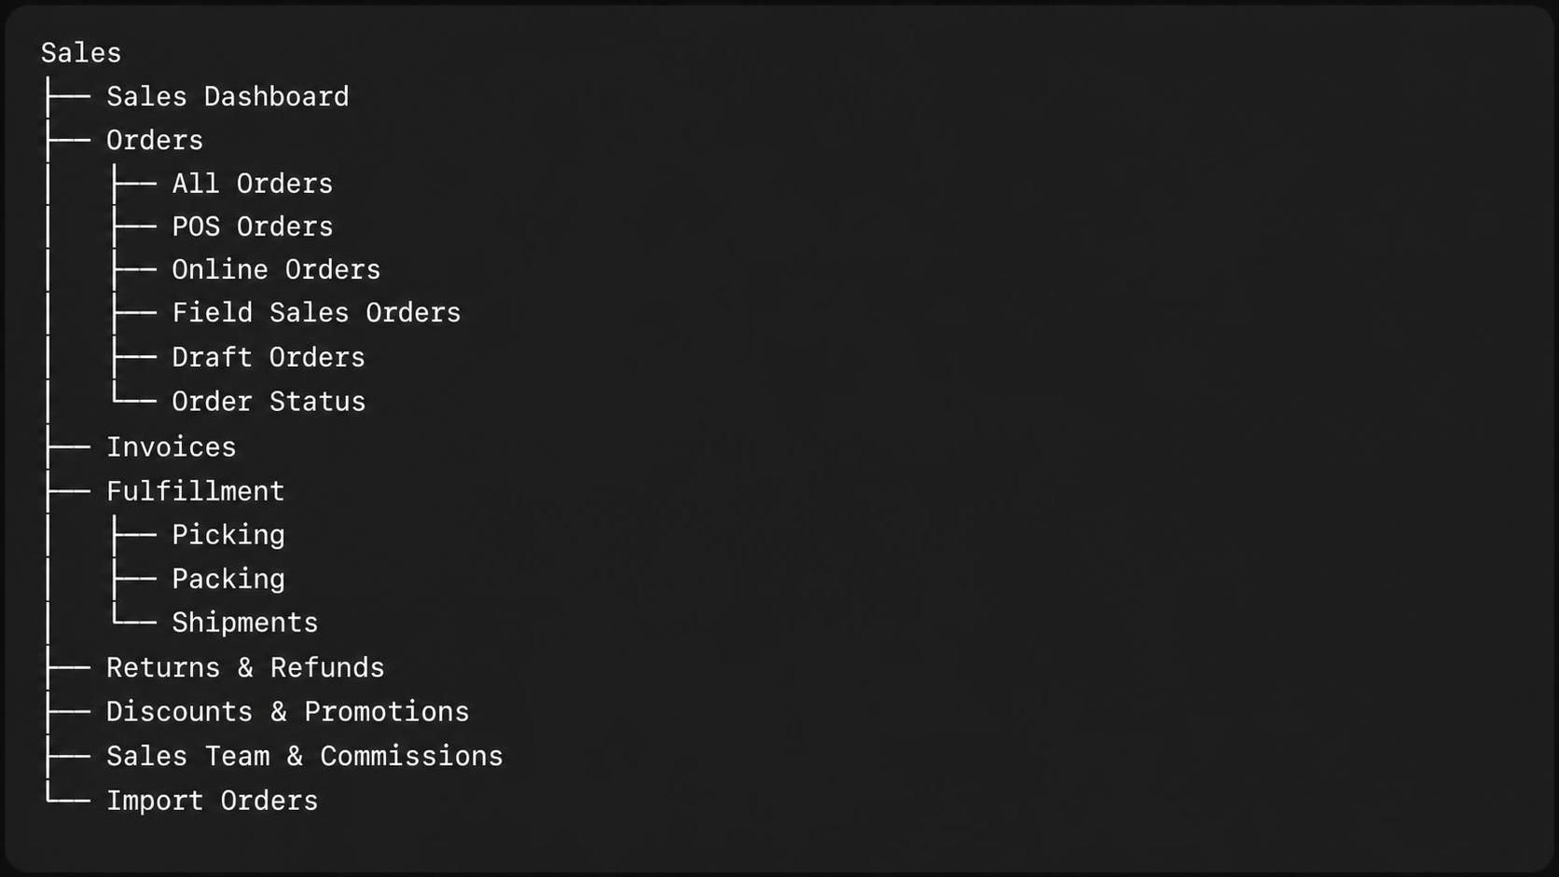

Any order placed through Online Orders or Field Sales Orders automatically enters the Fulfillment pipeline at the Picking stage — no manual routing needed."
Source tagging requirement:
"Every order that enters Fulfillment must retain a visible source tag indicating whether it came from Online Orders or Field Sales Orders. This tag should be:
- Stored on the order record itself (e.g., an order_source field), not just inferred
- Displayed on the Fulfillment views (Picking, Packing, Shipment) as a badge or label next to each order
- Filterable — staff should be able to filter the Fulfillment queue by source (e.g., view only Online Orders awaiting picking)"
Stage-by-stage flow:
- Picking — Order lands here first, tagged with its source. Warehouse staff picks the items and marks it ready.
- Packing — Once picked, order advances to Packing, source tag still visible.
- Shipment — Once packed, order moves to Shipment. This is the final stage — order is complete once shipped.
Picking Page:
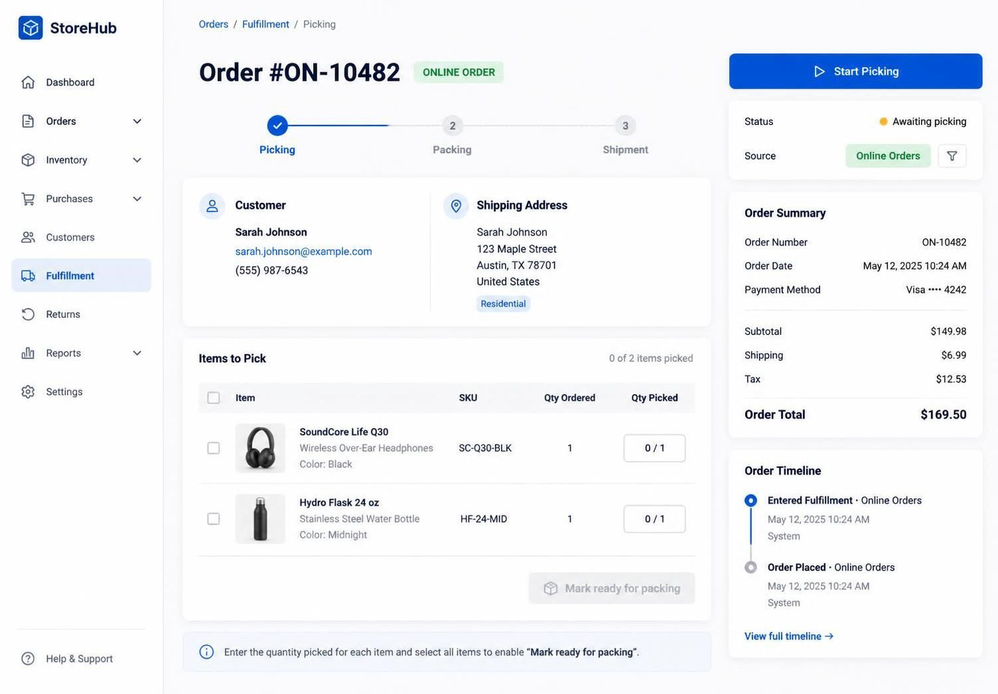

Packing Page:
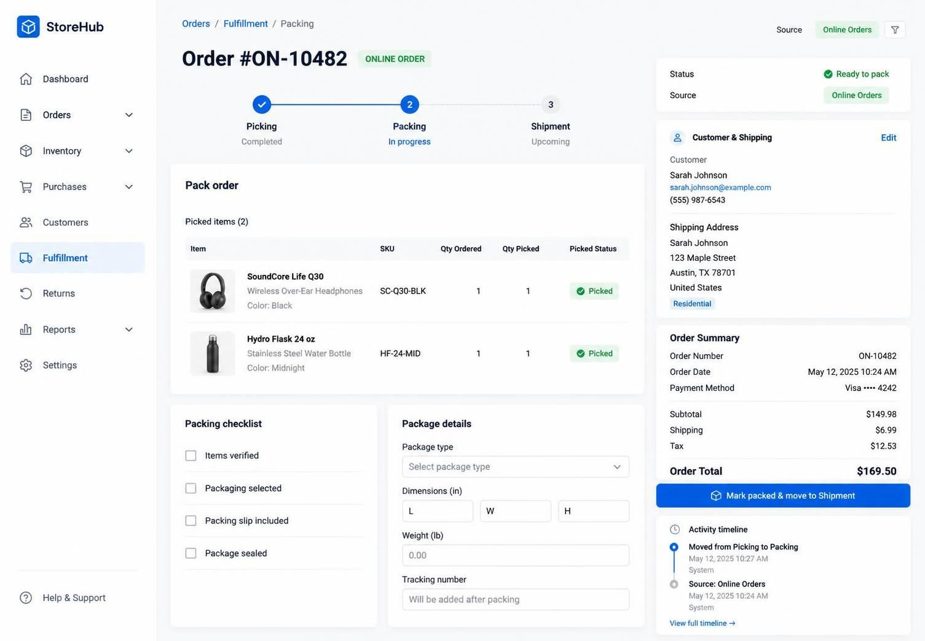

Shipment Page:
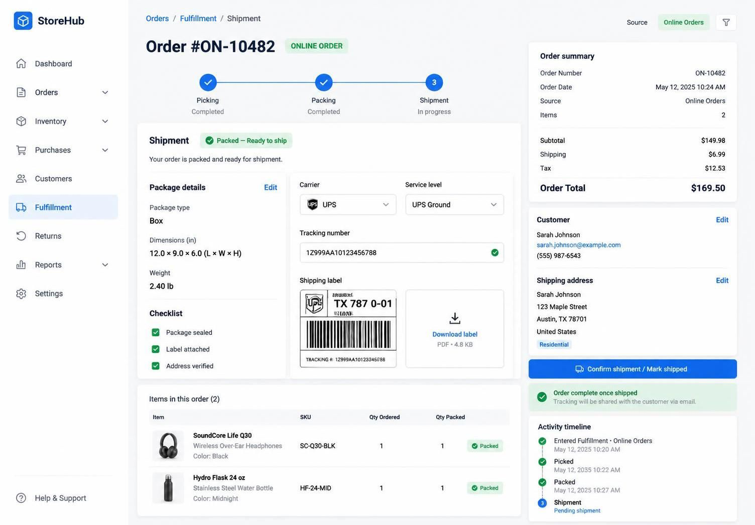
CRM

- Dashboard
- Customer
  - Customer
  - Customer Groups
- Leads
  - Leads
  - Pipeline
  - Follow Ups
  - Call Log
- Settings

REPORTS
- Business Overview
  - Profit & Loss
  - Cash Flow
  - Expense Report
  - Register Report
- Sales
  - Sales Summary
  - Sales by Customer
  - Sales by Product
  - Sales Representative
  - Customer Groups
- Purchasing
  - Purchase Summary
  - Purchases by Product
  - Purchase Payments
  - Suppliers
- Inventory
  - Stock Report
  - Stock Adjustment
  - Inventory Valuation
  - Items Report
  - Trending Products
- Customers & Suppliers
  - Customer Report
  - Supplier Report
  - Customer Groups
- Taxes & Compliance
  - Tax Report
  - MSA Tobacco Report
- Employees & Activity
  - Time Clock
  - Sales Representatives
  - Activity Log

